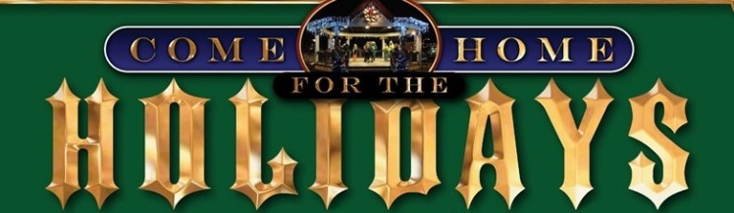
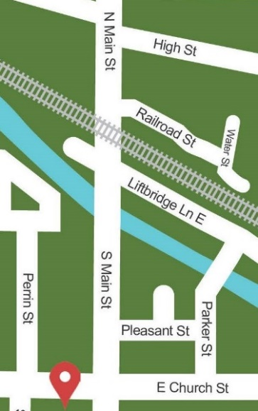
Fairport Gnome Homes
Visit Gnome Homes at the Following Locations
Visit business websites for hours of operation

- Bayberry Fairport
7 W Church Street
- Fairport Museum
18 Perrin Street
- Moonlight Creamery
36 West Avenue
- Fairport Public Library
1 Fairport Village Landing
- The Corner Bookstore
106 Fairport Village Landing
- Red Bird Market
130 Fairport Village Landing

- Evans Bank
45 S Main Street
- 1st Congregational United Church of Christ
26 E Church Street
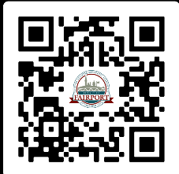
- Clementine Coffee
6 N Main Street – Box Factory
- Lift Bridge Yarns
23 N Main Street
- Fizzy Bombz
24 N Main Street
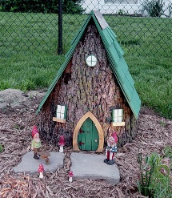
- RV&E Bike and Skate
40 N Main Street
- Created By Us Pottery
3 Railroad Street
- Affaire de Chocolat
66 N Main Street
- Firehouse Woodworks
113 N Main Street
- Iron Smoke Distillery
The Cannery
- Another Chapter Bookstore Fairport
24 High Street

When you have visited all locations, turn in your card
at the Fairport Public Library for a Holiday treat!

